Educating for Energy Efficiency: Exploring the Impacts in Virginia’s Affordable Housing Stock

A Highlight Report to Housing Virginia
January 2019

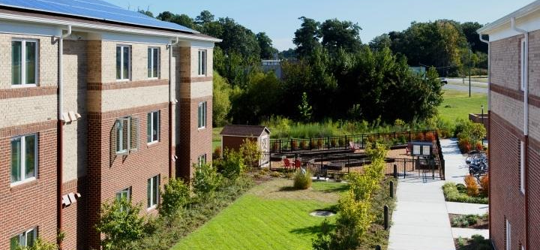

Virginia Center for Housing Research at Virginia Tech
Frederick Paige, PhD  Assistant Professor  Dept. Civil & Environmental Engineering  Virginia Tech  freddyp@vt.edu | Dong Zhao, PhD  Assistant Professor  Dept. Construction Management  Michigan State University  dzhao@msu.edu | Andrew McCoy, PhD  Director  Virginia Center for Housing Research  Professor, Dept. Building Construction  Virginia Tech  andrew.mccoy@vt.edu
Philip Agee, M.Eng.  PhD Candidate  Dept. Industrial & Systems Engineering  Virginia Tech  pragee@vt.edu | Yunjeong (Leah) Mo  PhD Candidate  Dept. Construction Management  Michigan State University  moyunjeo@msu.edu

Executive Takeaways

Findings suggest the following executive take-a-ways about educating residents on energy efficient technologies in the affordable rental stock in Virginia’s LIHTC program:

✓ Senior residents lack the knowledge required to optimally utilize the energy efficient features of their housing units

✓ Energy consumption feedback should be provided to residents in real time with personalized messaging for the resident population

✓ The Energy Literacy of senior residents can be positively impacted by their participation in a Targeted Education Intervention (TEI)

✓ Senior residents can become more aware and motivated to conserve energy through participation in a Targeted Education Intervention (TEI)

✓ Residents participating in this study expressed an improved understanding of the following energy literacy concepts:
○ Human use of energy is subject to limits and constraints
○ Electricity is generated in multiple ways
○ Energy use can be calculated and monitored

✓ Residents participating in the study expressed a limited understanding of the following energy literacy concepts:
○ Social and technological innovations impact energy use
○ Conservation is one way to manage energy resources

✓ Energy Feedback Displays create intended and unintended human-building
interactions; to maximize benefits of new technologies, educational efforts must be
frequent and thorough to meet efficiency goals.

Table of Contents
Executive Takeaways 2
Table of Contents 3
List of Tables 5
List of Figures 6
List of Definitions 7
Introduction 8
Background 8
Sample Characteristics 10
Sample Methodology 11
Key Takeaways 13
3yr Energy Data (EEC Sample) + Education 13
Targeted Education Interventions 14
Conclusion 15
Limitations 18
References 19

The Virginia Center for Housing Research (VCHR) is the official housing research center for the Commonwealth and is a college center in Virginia Tech’s College of Architecture and Urban Studies. VCHR provides services to localities, the state, federal agencies, nonprofit organizations, and for-profit businesses.

List of Tables

Table 1. Project sample summary

Table 2. Energy Feedback Display budget planning and analysis

Table 3. Energy Literacy scores pre and post by concept.

Table 4. Energy literacy intervention effect by concept.

List of Figures

Figure 1. Timeline of VCHR’s Energy Efficient Construction (EEC) research.
Figure 2. Residential electricity price trends 1990-2018. Source: U.S. EIA
Figure 3. The research team led residents through targeted education using videos and PowerPoint.
Figure 4. a) six residents received Targeted Education Intervention (TEI) and b) an Energy Feedback Display (EFD)
Figure 5. Sample project (n = 38 apartments), 5 years of monthly energy use.
Figure 6. Average energy use of all units by category (TEI, TEI+EFD, Control).
Figure 7. Average monthly energy use (kWh) of interviewed units, TEI units, and control units.
Figure 8. Daily heat pump performance measured at the circuit-level for the TEI+EFD group.
Figure 9. Correlation between energy literacy score and energy usage.

List of Definitions

Average Monthly Energy Usage: Average Monthly Energy Usage refers to actual kilowatt-hours (kWh) of energy used by residents per month averaged across the entire sample.

EarthCraft: is a green building certification program that serves the Southeastern United States. Over the course of the program’s 18 year history, more than 40,000 homes, multifamily units and light commercial spaces have been certified.

Energy Feedback Display (EFD): is a technology used to provide residents with real time energy consumption feedback from their apartment; energy consumption feedback is provided through an interface that utilizes color and light to inform the user (e.g., resident) of the impact of their behavior on energy consumption.

Energy Literacy Guide: is a guide composed of 7 essential principles and 49 fundamental concepts relating to energy. Over 20 recognized educational partners and 13 federal agencies that comprise the U.S. Global Change Research Program partner agencies collaborated to create “Energy Literacy: Essential Principles and Fundamental Concepts for Energy Education”. This interdisciplinary guide was created for a broad audience k-Gray, with the intent to improve formal and informal energy education experiences. The five concepts used in this study are: 1) human use of energy is subject to limits and constraints, 2) conservation is one way to manage energy resources, 3) electricity is generated in multiple ways, 4) social and technological innovations affect the amount of energy used by society, and 5) energy use can be calculated and monitored.

Human Building Interaction (HBI): is a user-centered approach that focuses on how occupants interact with buildings to consume energy and employs the design thinking process to guide the innovation process and produce effective solutions.

Low-income Housing Tax Credit (LIHTC): the largest low-income rental subsidy in the U.S. that serves as the primary catalyst for rental housing development.

MELs (Miscellaneous electric loads): are human-centered building energy end-uses (lights, appliances, and plug loads such as televisions, toaster ovens, and space heaters).

Zero energy building: a building that produces as much energy on site annually as it consumes; energy production is typically accomplished using solar photovoltaic panels.

Introduction

This study explores the impacts of targeted resident education on energy consumption and occupant experiences in affordable, multifamily housing. The work builds on a multi-year, interdisciplinary research agenda aimed at evaluating the impact of energy efficient construction on Virginia’s affordable housing portfolio. Over the last seven years, the authors have studied performance outcomes in EarthCraft Multifamily (ECMF) developments in Virginia’s LIHTC portfolio (see Figure 1). Each study has informed the direction of future research efforts and research methods utilized to unpack complex micro and macro-human-technology relationships in housing systems. Important factors that have been examined over the last seven years include energy use, resident behavior, construction costs, and resident education. While this research has specifically focused on affordable, multifamily housing in Virginia, findings from these studies have elements that can be generalized and inform practitioners, utilities, and policy makers working to make housing more energy efficient and affordable.

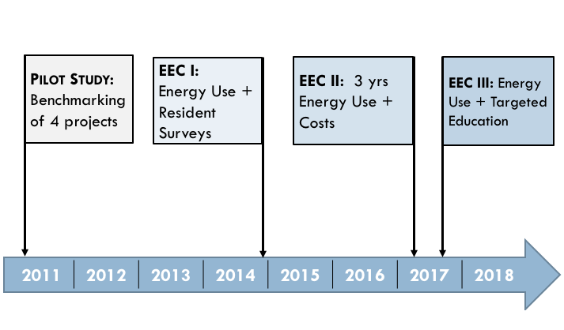
Figure 1. Timeline of VCHR’s Energy Efficient Construction (EEC) research.

For the following report (referred hereafter as EEC III), the researchers focused on a single, senior LIHTC development that was designed and constructed to the EarthCraft Multifamily (ECMF) rating system. The property was completed in the summer of 2013 and is managed by an experienced Virginia-based non-profit housing provider that develops and manages a number of housing types (e.g., multifamily senior, multifamily family, single-family detached, single-family attached).

The VCHR project team is motivated to focus on a senior LIHTC development by a number of factors that reflect important housing trends across the Commonwealth of Virginia. First, senior housing represents a growing housing need in Virginia. The over-65 population (hereafter referred to as senior) is expected to increase from 14% to 19% of total Virginia housing occupants, a considerably rapid increase compared to 20-64 age group (Jones et al., 2017). Second, previous work by the authors (McCoy et al., 2017) found that seniors in new construction LIHTC developments consume more energy on average than family and/or renovated LIHTC projects. Finally, senior housing residents have unique human factors that influence human-building interaction (HBI) experiences compared to non-senior residents. Providing quality housing for this demographic will require a new approach from our current design standards. The Virginia Center for Housing Research strives to provide solutions to meet the state’s growing need for senior housing while promoting affordability through energy reduction in the built environment.

The objective of this research is to understand the impact of educational interventions that encourage EE in the affordable rental stock in Virginia through examining residential energy usage, technology, and behavior in the LIHTC program. The research presents results from educating Virginia’s affordable housing residents on energy efficiency, exploring behavioral changes, energy literacy shifts, and energy consumption.

Background

ENERGY EDUCATION FOR SENIOR OCCUPANTS. Previous work by the authors identified the energy efficiency education for occupants as an important research direction and opportunity to maximize the efficacy of energy efficiency investments in the housing industry (McCoy et al., 2015). Despite management’s effort to educate tenants on technology in their units, a majority of residents in the EEC sample (n= 237) report no education on their apartments and feel that they lack understanding of the technology in the unit. As technology becomes further integrated into the unit, user education for residents becomes critical. As our population ages, seniors stand to benefit from technologies which improve health and wellbeing in housing. For example, McCoy et al., 2017 reported that residents that received education on their apartments had a lower average energy usage monthly and annually (over 3 years) by almost 15% (14.8 %) and a lower energy bill by $10.56 per month.

Previous research has found that seniors are motivated to use technology once they are informed of their benefits (Melenhorst et al., 2001). Further, Czaja et al., (2009) found that senior technology adoption depends on their understanding of the benefits of the technology, income level, and ease of use. In order to retain and put lessons into action, seniors also have unique needs in regards to the delivery of their education. Education delivery should avoid passive observation, and should instead utilize the exact interface or technology that is the focus of the educational intervention (Salvendy, 2012). Recognizing the unique needs of housing occupants will become critically important as we invest in energy efficient housing and and our broader energy infrastructure.

INFRASTRUCTURE INVESTMENT AND ENERGY EFFICIENT HOUSING. In March 2018, SB 966, commonly referred to as the Grid Transportation and Security Act (GTSA) was signed into Virginia law. The GTSA represents one of the largest investments in transforming Virginia’s energy infrastructure toward a more efficient, resilient future. As a result of GTSA, Dominion Energy and American Electric Power Co. (AEP) will invest $1.2 billion toward energy efficiency and low-income energy assistance programs over the next 10 years. Dominion Energy alone will invest $870 million in energy efficiency programs with at least 5% of the funds earmarked for low-income customers. This study is a timely precursor examining energy efficiency investment outcomes and targeted education benefits in all electric, low-income housing. The results from the collective EEC work can be viewed and leveraged by utilities, practitioners, and policymakers as a proof of concept and benchmark for investing in Virginia’s housing infrastructure.

Energy efficiency investments have traditionally been heavily based upon building simulations. An underlying assumption of building simulations are that occupants will utilize a building’s design in a logical manner. Occupants energy literacy is a key variable in building optimization. Many energy efficient building certifications, and the Department of Energy (DOE), strongly suggest or require some type of education to be provided to occupants of energy efficient building systems. Without an understanding of energy, or energy efficient home design features, cost effective energy efficient buildings are not feasible. Without energy literate operators, costly automation features, and oversized generation systems are recommended to mitigate inefficient energy consumption behaviors.

Energy literacy has been a topic of national interest. In 2012, “Energy Literacy: Essential Principles and Fundamental Concepts for Energy Education” was published by the DOE, 20 educational partners, and 13 federal agencies. The purpose of the guide is to improve both formal and informal energy education experiences. Since creation, the guide has been updated and leveraged to create teaching modules, educational videos, and frameworks for research studies.

The data analysis for this study was framed by the DOE’s Energy Literacy guide (DOE, 2012). Principles and concepts in the guide have a great deal of overlap and the most critical concepts were selected as a scope for this study. Concepts were prioritized in regards to their connection to the TEI and in-home experiences. After the concepts were prioritized, the scope of this study was set to fit the limitations of the data collection and analysis methods utilized. The research team selected five concepts to bound this study which link to daily energy decisions and the targeted energy education we provided: 1) human use of energy is subject to limits and constraints, 2) conservation is one way to manage energy resources, 3) electricity is generated in multiple ways, 4) social and technological innovations affect the amount of energy used by society, and 5) energy use can be calculated and monitored.

Previous studies have shown linkages between personal pro-environmental behavior, such as efficient energy use, and level of education (Poortinga, Steg, Vlek,, 2004) (Nair, Gustavsson, Mahapatra, 2010). Targeted occupant education has been shown to be an effective method for reducing energy consumption (Delmas, Fischlein, Asenio, 2013) (Zografakis, Menegaki, Tsagarakis, 2008) and in a previous phase of this study, education strongly correlated with reduced energy consumption (McCoy et. al. 2017). Logically, the cost of energy is a motivator of energy efficient behavior, but even residents who are not financially incentivized to conserve energy have developed energy saving behaviors through education (McMakin, Malone, Lundgren, 2002). This study attempts to look further into how education can impact energy consumption and pro-environmental behaviors of senior residents.

Providing an education to residents is not only the appropriate ethical choice, educational programs can also be powerful business strategy for builder-developers. Figure 2 graphs residential electricity price ($/kWh) trends for the United States and Virginia from 1990-2018. Virginia electricity pricing is trending with national pricing. Virginia electricity prices have increased by an average of 1.5% per year over 25 years and 3% annually over the last ten years.

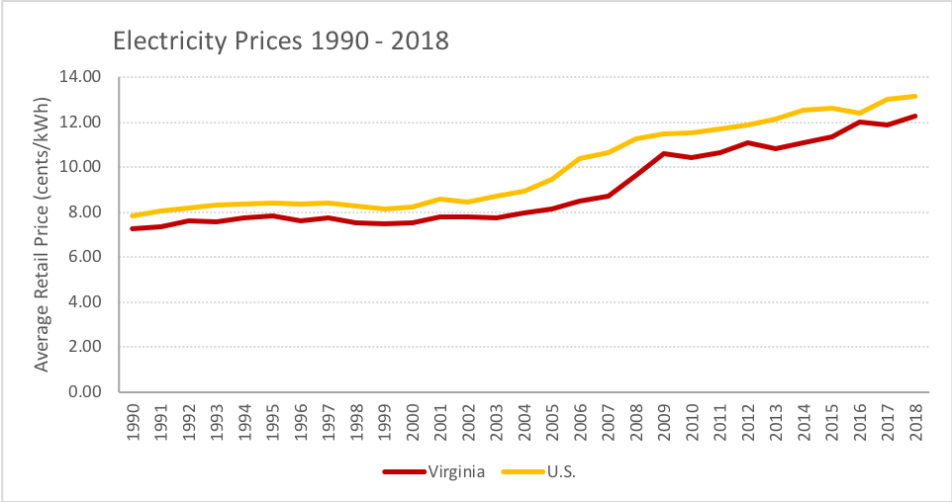
Figure 2. Residential electricity price trends 1990-2018. Source: U.S. EIA

Based on these trends, Virginia LIHTC builder-developers could expect a 22.5-45% increase in electricity costs over the 15 year tax credit project compliance period. In tenant paid, sub-metered developments, affordability is directly impacted by rising energy costs. If the electricity is sub-metered and paid by the resident, residents are directly impacted by the raising electricity costs. Conversely, builder-developers who own properties with sub-metered, property manager paid utilities, redirect the impacts of rising electricity prices back to their customers indirectly. The misalignment between electricity cost burden and building investment creates a split-incentive. A split-incentive occurs when one party (builder-developer) invests in efficiency improvements, yet another party (the renter) receives the direct benefit of reduced utility bills. The split-incentive of builder-developer investment in energy efficiency with the tenant receiving the direct benefit has been described as a market failure and burden to widespread adoption of energy efficiency in multifamily housing. The housing industry must structure the development of energy efficient homes to foster financial incentive alignment for builders, property managers, and occupants.

A current improvement to the energy efficient housing system is the development of energy performance tracking methods. Property managers should not rely on traditional utility billing technology to understand the performance of their system; this would create an informational lag. Human factors researchers have reported that people are generally poor at managing systems with lags in information and delayed feedback loops (Brehmer, 1992; Sterman, 1989). In energy efficient housing systems, energy monitoring systems should be installed in each unit to report energy use in real time using an Energy Feedback Display (EFD) for occupants. Using the same hardware, building managers can utilize cloud-based software platforms to monitor and create performance reporting, instantly being aware of system failures or inefficiencies. Studies have shown that EFDs have improved behavior towards a more energy efficient lifestyle and resulted in 10-15% monthly energy use reductions provided it was: a) given frequently; b) provided over long periods of time; c) with appliances characterized individually; d) presented in clear, appealing ways; and e) utilizing computerized, interactive tools. (Stinson et al. 2015; Martinez & Laitner, 2010; Ouyang & Hokao 2009; Fischer 2008). Reducing informational lag and educating stakeholders such as property managers and occupants is a critical next step for investing in energy efficient housing in Virginia.

Methodology

This study is a singular case study in continuation of a multiphase statewide longitudinal study (McCoy et. al. 2015). Building upon findings in the last phase of the longitudinal study, this case study utilizes interviews, field observations, surveys, and energy consumption data to explore the impact of targeted education on residents energy consumption behavior, beliefs, and literacy.

Guiding Questions:
How does targeted energy education and energy consumption feedback impact energy literacy of seniors in zero energy apartment units?

How does targeted energy education and energy consumption feedback impact energy consumption of seniors in zero energy apartment units?

Sample Characteristics
The case utilized for this work is a senior living LIHTC project in Richmond, VA that has been being monitored since 2013. This property was selected for its unique occupant energy consumption patterns and design features. While the property was performing better than average building nationally and in Virginia, the property was falling short of its zero energy goal.

Participants in this study were surveyed using a hand-written survey at their development in a community room. The survey was developed from previous instruments (McCoy et al., 2017; DeWaters 2009) adapted for use in this case. Surveying in person requires a great deal of flexibility and effort. Surveys were designed to be senior friendly utilizing large fonts, high contrast, and large formatting for recording responses. Even so, multiple participants needed assistance while taking the survey. A team of two researchers was present to administer the survey with one researcher reading the questions aloud to the group and the other researcher assisting participants one on one when necessary. Working with the property managers was essential for delivering this education and survey. Property managers helped with recruitment and provided light refreshments during the education and pre survey. A $25 gift card was provided by the research team during the pre and post survey, to participating residents to aid in recruitment.

A semi-structured interview protocol was developed around the five energy literacy concepts.. Questions were open ended and repetitive, prompting participants to describe their in home experiences and lessons learned. The survey questions were coded to the energy literacy guide providing descriptive data on the lessons learned by the study participants.

The recruitment efforts resulted in twenty residents attending a one-hour community meetings and receiving a Tenant Education Intervention (TEI). Of the twenty residents, twenty successful records were developed for analysis. Six residents who received the TEI, also were provided with an in-home display. Seven participants, with three being residents with an in home display, were interviewed as a part of this study. It is important to note that the researchers were able to leverage the existing energy use data from previous work to compare monthly energy usage and the efficacy of resident education efforts. An overview of the project’s sample is provided in Table 1.

Table 1. Project sample summary
 | Total Units | Targeted Education (TEI) | Targeted Education (TEI) + In-home Display | Control
Units | 38 | 20 | 6 | 18

Educational intervention
There are two interventions in this study delivered in the following formats: 1) residents who received a Targeted Energy Intervention (TEI) (see Figure 3) and 2) residents who received a TEI + an energy feedback device (see Figure 4). The TEI consisted of the authors guiding residents through seven educational videos and a ten minute PowerPoint presentation that featured technologies specific to their apartment.

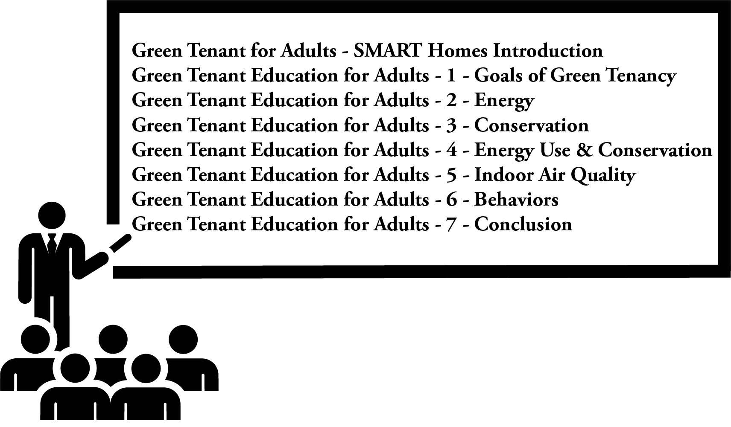
Figure 3. The research team led residents through targeted education using videos and PowerPoint.

 | 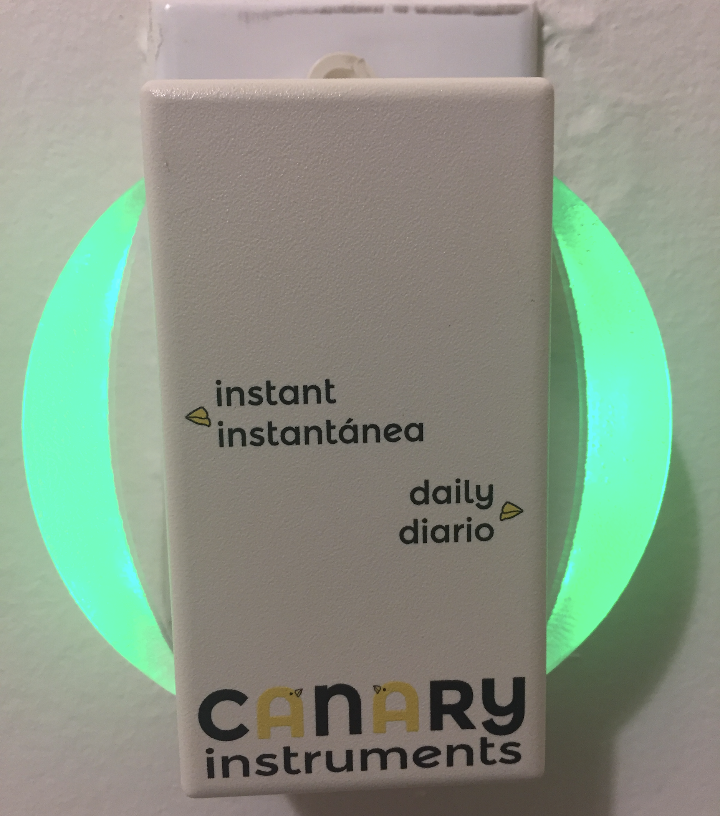
a) | b) | c) | d)

Figure 4 a) six residents received Targeted Education Intervention (TEI) and an Energy Feedback Display (EFD. The EFD was programmed with a daily energy budget that reflected energy behavior with a dynamic color display. b) EFD interface reset at midnight. c) high realtime consumption and 20% of daily budget consumed, d) low realtime consumption, 70% of daily budget consumed.

The research team considered several factors when developing the daily energy budget for the EFDs. First, the HER’s energy simulations that were developed during design were reviewed. Second, historical energy use data for the selected apartments were analyzed to develop an average kWh/day per apartment. Finally, the team established the energy reduction goals to be programed into the EFD devise. Table 2 provides and overview of the estimated, measured, and EFD budgeted energy goals.

Table 2. Energy Feedback Display budget planning and analysis
 | Unit A | Unit B | Unit C | Unit D | Unit E | Unit F | Unit G
Estimated kWh/day | 3.94 | 3.94 | 3.94 | 3.94 | 3.78 | 3.62 | 3.62
Measured kWh/day | 7.99 | 8.96 | 9.39 | 7.47 | 11.03 | 12.07 | 9.40
Social kWh/day | 6.78 | 6.78 | 6.78 | 6.78 | 6.78 | 6.20 | 6.20

Results

The following section unit-level and circuit-level energy consumption graphs. The team has been benchmarking energy use at the property for five years - see Figure 5. Figure 6 compares energy consumption of each samples class, as well as each class’ consumption from the previous year. Figure 7 compares the monthly energy consumption per each class and provides average monthly energy consumption trend lines.

Unit Level Energy Consumption
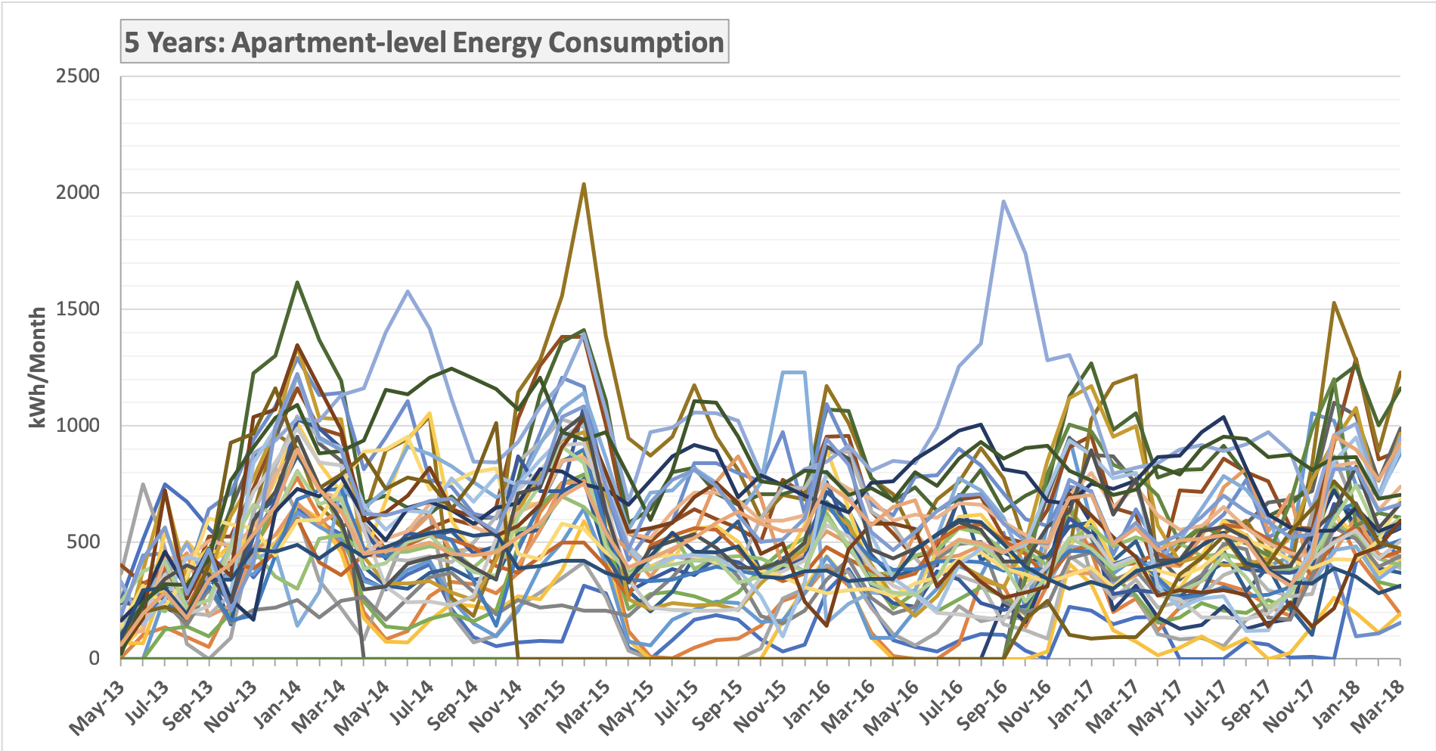
Figure 5. Sample project (n = 38 apartments), 5 years of monthly energy use.
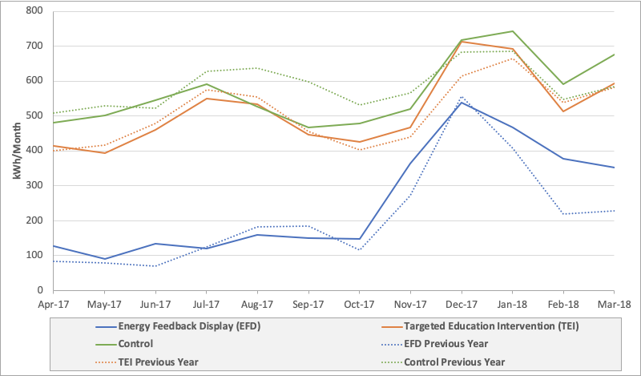
Figure 6. Average energy use of all units by category (TEI, TEI+EFD, Control). Note TEI + EFD apartments have solar PV and continuous exterior insulation.

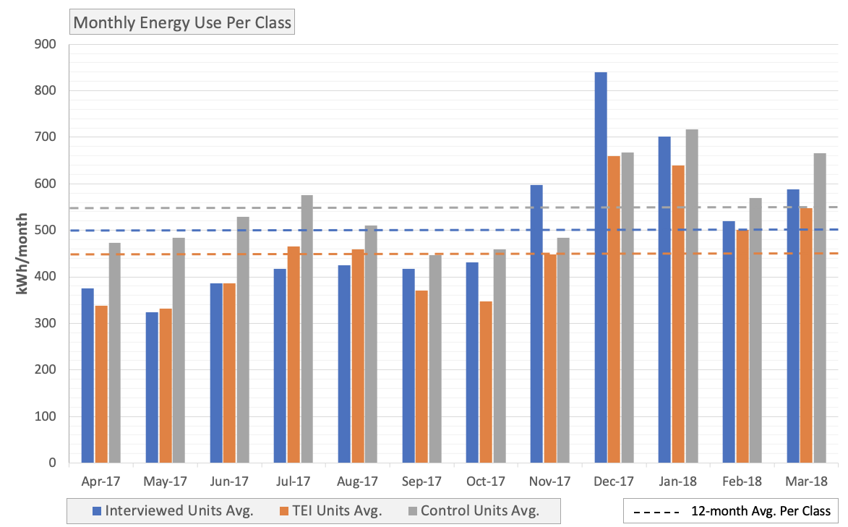
Figure 7. Average monthly energy use (kWh) of interviewed units, TEI units, and control units.

The energy consumption for the units followed the same patterns from year to year with an increase in the consumption for the EFD units in the winter months of January, February, and March 2018. On average, the TEI units performed better than the control units. The interviewed units started to increase in relative energy use compared to the other groups which may be due to an increased belief in the energy offsetting ability of the solar panels on the property. Researchers intentionally did not stop the residents from communicating energy literacy information with each other whether it be factual or flawed.

Circuit Level Energy consumption

The EFD units include circuit-level energy monitoring capability. For example, circuit transmitters (CTs) were placed on the two main electrical lines in the apartment’s panel box. Three additional CTs measured energy used at 1 second intervals. The team monitored the heat pump, water heating, and dryer circuits. Figure 8 charts daily heat pump performance and ambient temperature from September 10th, 2017.
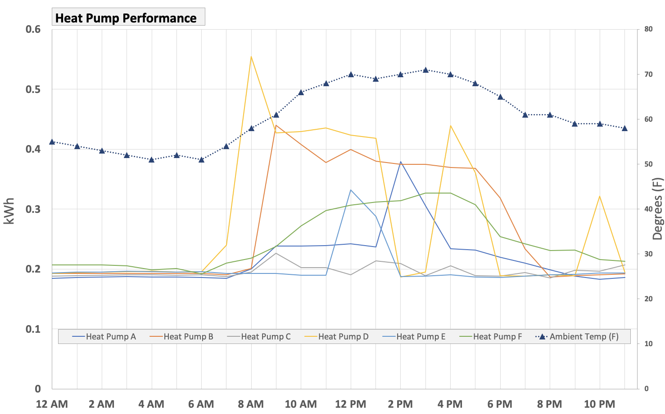
Figure 8. Daily heat pump performance measured at the circuit-level for the TEI+EFD group.

Energy Literacy Survey

Concept 1: Human use of energy is subject to limits and constraints
Concept 2: Energy use can be calculated and monitored
Concept 3: Electricity can be generated in multiple ways
Concept 4: Social and technological innovations impact energy consumption
Concept 5: Conservation is one way to manage energy resources

Table 3. Energy Literacy scores pre and post by concept.

Table 4. Energy Literacy intervention effect by concept.
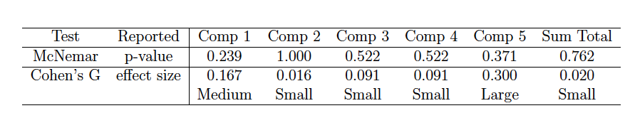
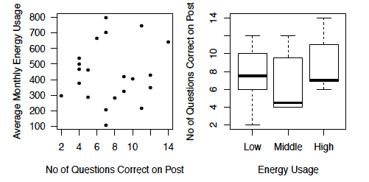
Figure 9. Correlation between energy literacy score and energy usage.

The energy literacy survey utilized for this study was provided to study participant pre and post the educational intervention. The shift in scores was found to be statistically insignificant in regards to having participants change from selecting an incorrect answer to a correct, and vice versa. Scores did not correlate with energy usage and there was a large range between the scores of low, middle, and high energy users. The educational intervention did show to have a large effect size for concept 5 which aligned with the qualitative data discussed later in the report.

Interview Responses

The following results are from seven semi-structured interviews which were coded descriptively. The following key assertions were developed with representative quotes shown in italics.

Participant definitions of energy varied greatly.

“Energy, goodness gracious I hadn't even thought of. Energy is when you think about a dam or solar panels or the wind turbines that generate energy. Energy is confined ... atoms that produce heat and water and things that sustain the human body and the environment.”
Without a common understanding of what energy is, educational efforts to improve occupant behavior will fall short. Participants described energy using a wide variety of words and examples. A simple common understanding did not present itself. There was a common relation of energy to the human body provided by multiple participants. In their responses, participants accurately discussed how to use energy with speed and rigor, but less confidently described energy or where it comes from. One participant directly stated remembering learning about the sources of energy in the TEI.
When sources of energy were described, food and common electricity generation methods were discussed such as fossil fuels, dams, solar panels, and wind turbines. Beyond the body connection, participants also visualized/conceptualized energy using a pseudo physical representation. Even though participants were asked to describe energy in their own words, a textbook type of vernacular was delivered by participants using words like atom, conductors, AC/DC, combustions, force, speed, distance. Other common terms which were used to describe energy such as light, burning and heat were shared with varying levels of confidence and accuracy.
An expressed interest in behavioral change was common among participants.

“The way you run it, that circulates it in the room and it's good. I don't like it too cold or too hot in my bedroom and I'll cut just this one [mini split] on in here and I'll use my fan and it pushes it back to the other rooms and I don't have to have the air conditioning on back there.”

When asked about the impacts of participating in this study, participants described a growing sense of consciousness about energy. While all of the participants expressed a positive interest in improving their consumption behaviors, there were varying levels of confidence in their ability to make informed behavioral changes. As shown in the survey responses of this study, and previous surveys (Atari, 2014), many residents do not understand how to prioritize their energy saving behaviors. All of the participants expressed feeling of wanting to know how to reduce their energy consumption even more.

Appliance use was a recurring trend as an important behavioral change. TVs were a particularly popular appliance with discussions about purchasing energy efficient models and turning off the TV when not in use. Air conditioning was also a major concern for participants. Thermal comfort is a priority, particularly for senior residents, and the energy efficient mini-split system installed in these units provided optimal thermal comfort for the participants of this study with a caveat. Participants expressed that they only utilized one mini-split at a time in the room in which they were not occupying. The ductless mini-splits in the studied building were positioned in a manner which would blow warm or cold air directly on occupants which was not appreciated by participants in this study. The mini-splits were also controlled by remotes with limited accessibility features. Participants also discussed turning off unused lights but mostly as a lesson they were already familiar with. Their participation in this study did reinforce their motivation to be conservative with their use of electric lighting.

Participants appreciated energy efficiency advantages of their current residence.

“I had to pay my light bill where I used to live. My light bill in the summertime was no more than $75 a month. In the winter time it was maybe $150 because of the heat and the ceilings were so high.”

A general appreciation for energy efficient housing units were described by the participants. The stability in cost of living was highlighted consistently. Participants described their units to be more energy efficient than their previous dwelling by design and physical proximity to senior resources within the greater community. The property is close to senior programming, public transportation, and food services. Access to laundry units, in or near the apartments, was also highlighted as very useful.
The mini-split heat pumps were given particular attention when participants described the energy efficient features of their current residence. Thermal comfort was a concern for some in regards to how they heat and cool the apartment units. The senior residents were not fond of how the units blew warm or cold air directly on them. Nevertheless, participants expressed an understanding of the energy efficiency advantages of ductless units.
Multiple system failures inhibited the performance of the studied buildings.
“you don't have enough space to put your things”

“Honestly, I like that heater. I like that heater ... when it's working properly. When it's not leaking”
There were multiple system failures identified in relation to studying the performance of the building in this study. Failures were identified during the interview process via participant response. The most common failure relates to the mini-split systems. Multiple units had mini-splits which failed by one or more of the following: leaking water, poor mini-split placement (e.g., blowing air directly on occupants), and space heater supplementation. Another common system failures was the lack of energy monitoring of residents. Occupants expressed an awareness that their energy use costs money, but stated that they have a limited awareness of their consumption rates due to the inclusion of electricity in their flat rent. Monthly bills are provided by the utility to the property manager but consumption rates are not shared with the residents. By design, the property includes a solar system which in theory should provide enough energy to balance energy consumption with production throughout the year. Upon further examination, the solar system for the properties lacked an appropriate monitoring system. The only tracking of production occurred via net metering metrics on utility bills. In months with high solar generation, poor building performance could be masked by production. Even worse, in the event of a solar system failure or limited production, occupants could be blamed for increased energy consumption when the true cause of increased energy costs was the lack of solar generation.

Participants understood that energy use can be monitored but struggled to understand the calculation steps.

“The bill of course you have the wattage, and the uses, and this that and the other. And you sit and think about it, you had to pay it. Or your lights would be off until you paid it.”

Participants were not confident in their understanding of the process of calculating and monitoring energy use. Most participants were aware that energy could be tracked due to previous experiences paying electricity bills, recalling the TEI lessons, or from experiences with the EFD device provided as a part of this study. Understanding the fact that energy is quantifiable is a big step in the right direction, but being able to calculate energy consumption is critical to changing behaviors. An in depth understanding of how to calculate or monitor energy was not communicated by participants. The process of energy monitoring is mainly passive and calculation is handled by a third party or system. While many options for energy calculation exist, real time feedback devices are not widespread in the housing industry currently. Many home occupants are unaware of their ability to use their electrical panels to calculate and monitor their consumption rates. These units were sub metered, but the metering panels are locked away from occupants.

Participants also expressed a cognitive disconnect from their source of energy. Modern homes provide simple controls to complex energy systems with delayed feedback. Thousands of watts can be instantly demanded by pressing one button on a microwave. Advancement in housing technologies has increased system amperage and the number of connections. In other words, while buildings are becoming more efficient from an envelope and individual technology standpoint, the overall system is becoming less efficient due to increased access to energy.

The solar panels on top of the buildings helped participants to understand that electricity can be generated in multiple ways.

“Just like here people don't realize on the roof up here … is solar panels. They're gonna say, we don't have them here, they got them across the street."

An understanding of multiple electricity generation processes was communicated by participants with a varying level of understanding. Hydro-electric generation was the most commonly understood process with multiple participants discussing dams. Solar panels were also frequently discussed as a popular way of generating electricity. Solar generation is present on site for both buildings. One participant passionately described informing her neighbors about the out of sight solar panels on the taller building using google maps satellite view. The visibility of solar panels showed to be a very important factor in educating residents. The solar panels on the shorter building were visible from the windows of the community room in which the TEI was delivered.

Generally, participants highlighted renewable energy sources with positive attitudes. The participants are renters who do not have to deal with any of the negative aspects of solar energy such as maintenance or high upfront costs. With this passive connection to the solar panels on their apartment buildings, participants had little to no understanding of the full benefits of the solar system which offset their energy consumption behaviors. Some participants thought that the solar panels completely negated their energy consumption behaviors. When thinking about other options for generating electricity, participants blended electricity generation with consumption. A clear understanding of the never ending life cycle of energy was lacking in participants responses.

Social and technological innovations impact the amount of energy used by society.

“Everything's computerized now. Supposed to be saving energy but I think it's the worst thing they ever done.”

This study delivered both social and technological innovations to residents. A balance between the two types of innovations was communicated in interview responses. Participants described a need for communication to improve energy use, but also an emerging reliance on technology to communicate. The use of technology to communicate was perceived as a new increasing draw on energy resources. Across responses technology used to communicate was described as a negative. An over-reliance on social media and digital communication spaces was described by participants with little to no discussion about the positives of communicating via digital means. Participants also expressed that modern technology has a short half-life due to social norms which suggest that devices get replaced prematurely before the end of useful life.

Changing social norms was an important step towards reducing energy use according to participants. Messages about energy consumption were transferred throughout social networks, especially participants families, but the impact of the messaging was described as very dependent on context. When living in a parents home, habits are formed, but not necessarily transferred when moving to a new residence. It was stated that even after moving out, when an adult child returns to a parent’s home, habits are remembered even if they are not applied outside of the parent’s home. Participants described that energy lessons could be overruled by personal needs. For example, energy-conscious residents would like more security lighting on the exterior of the building regardless of the energy costs.

Energy conservation is important, with or without financial constraints.

“to me it's stupid to have the air conditioner on and the windows up. I mean ... but I see people do that.”

Generally, participants considered themselves to have an understanding of the importance of energy conservation. Multiple participants described their understanding of energy conservation being developed over time through experiences of necessity. The motivation for learning how to conserve energy was expressed as an effort to get the most out of the resources an individual can afford. Even without direct financial constraints, the participants of this study considered energy conservation to be important. Participants expressed a sense of confusion about how others consciously waste a resource as important as energy.

There was a dichotomy between beliefs about conserving energy to preserve natural resources, and conserving energy to preserve financial resources. Some participants believed there will always be accessible sources of energy, while others knew some energy resources were finite. Across responses, the conversation about conservation was described as very contextual. Energy conservation applies to decisions inside and outside of the home, but always very dependent on your environment. Appliance types, personal needs, and financial resources available all impact energy conservation behaviors. Participants want the messaging for energy conservation to be tailored to fit individual contexts instead of generic statements.

The limits and constraints of energy use only apply to some residents.

“I disa ... I agree in some ways and in some ways I don't agree because even with some restriction people gone do what they wanna do anyway.”

Participants described the limits and constraints of energy to be far away from their personal reach. Without ever experiencing a limit to energy, participants felt like there would always be enough energy to meet their needs. As stated before, participants were split in their beliefs about the earth being able to run out of usable energy. For participants who had experienced meeting an energy limit, they described running out of energy as a powerful lesson learned, but the experience was rare and temporary.

Constraints on energy were more commonly discussed in relation to financial resources. In the context of a home setting, reaching an energy limit will most likely result from having an unaffordable electricity bill. Conservation was described as a self-imposed constraint to ensure that the electricity would not be turned off due to delinquent payments. This type of interruption in energy use was not connected to energy being finite.

The design of a home, or its appliances, was also discussed in relation to energy use constraints. Participants described how energy intensive appliances can push occupants towards limits faster and create tighter constraints on behavior than energy efficient appliances. Onsite renewable energy systems such as solar electric generation were described as a way to offset and expand the limits and constraints on energy use. Discussion about the limitations of renewable energy sources did not present itself in discussion.

Conclusions

Residents do not have the knowledge necessary to optimally utilize the energy efficient features in their units. Furthermore, for the homes in this study to meet zero energy goals, changes in behavior and system design must be made. While the interventions utilized in this study did not reduce energy consumption, the process of analyzing this case revealed multiple issues in the current energy efficient housing infrastructure. By utilizing multiple methods and applying a socio-technical system lens, this study highlights breakdowns in the connections between systems which work fine in isolation. The following conclusions outline the major barriers to meeting energy goals, suggestions for improving the system design, and policy implications for moving forward as an industry.
The major barriers to meeting consumption goals in these units lie in the appliance utilization, and the limited operating knowledge of occupants. The homes were designed with energy efficient heat pump systems which are underperforming due to their placement, maintenance, and use schedules. Technically, the system was designed to be energy efficient, but the underlying assumption of optimal use cannot be met unless seniors are properly trained on how to efficiently use the system.
The TEI needs improvement to be more detailed and fitting for the senior population. While the education provided in this study briefly discussed the appropriate use of the technologies in this housing development, such as keeping windows closed and setting thermostats at a static set point temperature, it has shown to be too little too late. In future project designs, residents should be trained upon moving into housing units, and the system design must take into account the unique thermal comfort expectations of senior residents. There was an observed presence of space heaters, and a discussed preference to only use the heat pump in the room not being occupied by residents. By design, residents should not need to supplement their heat. These statements are not to blame the residents or the designers of the system. Instead, it is suggested that the delivery process of the housing units be developed in a more iterative and user-centered process. These housing units are novel in their area and a learning curve should be expected by all stakeholders in the system. While the TEI did not directly discuss the negative impacts of space heaters or other inefficient appliances, residents did learn the importance of only using efficient appliances to conserve energy. If provided earlier, education may improve users ability to operate the building systems optimally before supplementary appliances are purchased.
Residents want feedback on their energy consumption and incentives for conserving energy. In typical homes, there is about thirty days separating actions and feedback (utility billing). In the studied units, the delay was longer due to the utility bill being paid by the property manager. Feedback was primarily sporadic property wide discussions about over consumption. There were also a few mentions of utility bills being shared by the property managers. While the group studied in this case described being appreciative of their stable housing costs, disconnecting them from the price of their energy use seems to be coming with unintended negative consequences. The residents consistently stated they would like to be more informed about their consumption behaviors. The EFD utilized for this study sparked the interests of residents but was not able to reduce their consumption. A senior specific solution for feedback needs to be made taking into consideration their unique characteristics. Competition and gamification are popular strategies for incentivising feedback but they are mostly designed for younger age groups. The seniors studied in this group asked for simple and very personalized feedback about their consumption which also respected their lifestyle preferences such as warmer thermostat set points.
EFD’s still require improvements to be utilized effectively. The energy monitoring device we utilized in this study was not able to shift the behavior of residents. Real time direct feedback has been shown to reduce energy consumption by 15%, but this case lacked the required surrounding supporting context such as personal gain and operational understanding of the housing units features. In this case, the main motivator for energy conservative behavior comes from an intrinsic motivation to conserve for ethical reasons. The EFD utilized in this study lacked features which could consistently trigger an emotional response to over consumption. When changing a thermostat setting, or utilizing an appliance, residents are typically thinking about the positive end result such as improving thermal comfort or warming up a meal. Energy considerations come secondary and are usually triggered much later after the behavior. While the color wheel was selected to be a universal language for residents, the device is small and easy to overlook throughout the day. In future studies combining the color scale with other feedback measures may show to be more effective.
On the other hand, the property managers received direct feedback on their properties energy consumption, but unfortunately it was delayed and aggregated. Utility bills provided no feedback on their onsite solar generation and masked the specific sources of consumption. Property managers have a direct financial benefit for improving the performance of their building stock, but the novelty of this system unintentionally made it difficult for the property managers to optimize their buildings. The property was designed to be affordable with new energy efficient technologies and onsite generation, but the building simulations could not appropriately take into account the full reality of the system. Construction issues, hidden system failures, and a unique occupant population makes this case a great learning environment for researchers, but a tough property to manage in real time. While neither the property manager or occupant group wants to over consume energy, this scenario is the textbook definition of a split-incentive which creates many issues for groups to work towards a common goal.
To max out energy efficient efforts, educational efforts must be designed differently. To improve the system, an educational approach was taken suggested by previous work finding education as an important factor in supporting energy conservative behavior (McCoy et. al. 2017). Not only was a targeted energy education provided, but also a energy feedback display device was installed to educate residents and provide real time feedback. Neither education or energy feedback was found to have a positive impact quantitatively. In attempts to move beyond the limitations of quantitative methodologies, field observations and interviews were also used in this study which provided a deeper understanding of why energy usage was not reduced due to the interventions. While occupants energy literacy was shifting, their energy literacy remained relatively low, and there was a common confusion about how to reduce their energy consumption. Occupants were receptive to being provided an education but asked for a more detailed education process. Participants discussed being motivated to reduce their consumption but were unable to clearly discuss an effective strategy to reduce energy consumption post-intervention. Without an understanding of how to change their behavior, motivated occupants will continue to over-consume energy.
Upon moving into a unit, residents should be provided with a thorough education on their systems. Post-move-in education should be used as a supplement but should not be relied on as an independent intervention. The delivery of the education must be personalized beyond the unit to the individual or group of individuals habituating the space. This customization will require a large upfront effort but is necessary for shifting years of ingrained habitual behavior. There will be a learning curve for both the property manager and occupant when attempting to align efforts to operate an energy efficient building. Even with a thorough move-in education protocol, the context of energy efficient housing changes rapidly due to both social and technological innovations. Post-move-in educational efforts will help to keep the system up to date and well maintained. Within the year span of this study, multiple new technologies evolved, especially in the area of energy monitoring feedback devices. Since the development of the LITCH program, the political context around energy efficiency changed radically. With all of this change, it is difficult to manage risk and make the long-term decisions required of housing providers.
The average property manager will not have the capacity to develop and deliver a fully customized energy education, and energy efficient housing property, at an affordable cost if working in isolation. A menu of educational strategies, energy efficient products, and effective commissioning protocols must be developed and shared across the industry. At the surface level, installing an in-home display in each unit sounds like a feasible task. After becoming familiar with the system, an installer can complete an in-home display installation in as quick as 15 minutes. What is hard to account for is mislabeling of circuits, obstructions to the electrical panel and an appropriate location for the display. After installing the system, a property manager must ensure that occupants are able to properly read the display, and energy feedback must be adjusted to fit consumption patterns. Some systems are being built to automate the updating of feedback but these devices are still in the testing phase. Moving beyond the operation of an in-home display, analyzing the data output is not an easy task. The in-home display used for this study collects detailed one-second interval data which must be aggregated before it is analyzed. Both the process of providing an education and feedback need to be iterated multiple times before the industry will be ready to adopt the processes at a large scale.

Moving Forward | Closing the Gap
This study provides many implications for the Grid and infrastructure of the future. In the near future, utilities will be required to add in smart upgrades to the electrical grid. Population size and the density of energy consuming occupants are increasing. Add in the complexity of decentralized energy generation, and the increase in adverse weather conditions, old models for predicting energy demand will be obsolete. Two-way communication will improve the connection between energy users and suppliers, but all communication is limited by the abilities of the communicators. Both ends of the system must be designed with the human at the center of the system. At the residential end of the system, a large amount of energy demanded by the residential sector will eventually be controlled by smartphones. This evolution in technology will allow people to change the peak demands on the grid without even being at home. Unknowingly, occupants can continue to make energy predictions more and more complex. Investments in energy efficient devices and sustainable communities can be disrupted by the touch of an app. With the appropriate education, however that may look, home occupants can make informed energy decisions to request energy in a sustainable manner.
In this case study, a zero energy investment is performing well relative to a traditional housing development, but missing the predicted energy targets. When projected targets are not met, property managers in the affordable housing context will naturally be hesitant to continue to invest in technologies which impact the long-term operation of a building. The occupants of affordable housing also miss a great opportunity to profit from the full benefit of energy efficient housing. In this case, the costs are not forwarded on to the residents, but in many properties, the residents would be taking on the burden of the increased energy costs in this case. For seniors on a fixed income, small fluctuations in living costs turn into large fluctuations in their quality of life. This case was one of a kind in its area, but as energy efficient technologies diffuse and urban areas become denser, utility companies will rely on energy simulations to operate and maintain the grid. Many utilities have already begun to invest in measures to reduce peak demand and overall consumption. If large investments in energy efficiency fall short of their goals, eventually our existing energy infrastructure will fail to meet demands, leaving the most vulnerable populations without power.
In efforts to protect our most vulnerable, a more robust attempt to improve energy infrastructure must be taken. The system is too large and complex to be improved in a piecemeal fashion. A large systematic approach must be taken, crossing disciplinary boundaries, and utility areas of service. The solution to our energy problems will be a balanced approach, requiring both social and technological innovations. These solutions should not be created in isolation, and for a service as vital to life as energy, the solution must be shared broadly. The imbalance between the availability of services and technologies in the regions of the United States is already starting to show. Some states are making large improvements to the infrastructure supporting energy efficiency, while others wait years to be provided with the same product or service. Energy use is very contextual and great benefits exist for having small subsystems, but until all the subsystems understand their role and connection to the larger energy system, there will be many inefficiencies in the system. Occupants must understand the limits and constraints on their use. Property managers, utilities, and other organizations must understand the systems they put in place and the users they serve. Technologies must be made with human operation in mind, even automated technologies have unintended consequences which must be considered.

Limitations
It is important to recognize the limitations of this work. This report is built around a singular case study, the data, analysis, and findings focus specifically on one approach towards energy efficient design, a single type of in-home display, and one approach toward energy education. Other types of building designs, in-home displays, and energy education activities were beyond the scope of this exploratory study. The sample size of the study is a limiting factor in this work. Piloting education interventions is an important first step toward larger-sample studies that will help inform policy makers and housing providers regarding the efficacy of educational interventions in HPH housing. In its current state, data has been focused on the units and occupants. As stated before, there are multiple stakeholders who have an influence on the larger system such as building maintenance staff, builders/developers, utility companies, and more. This detailed look at education will provide us with guidance on how to expand from this smaller study to a larger look strategically.

References

Ang, A., Bekaert, G., &amp; Wei, M. (2007). Do macro variables, asset markets, or surveys forecast inflation better? Journal of monetary Economics, 54(4), 1163-1212.

Aroul, R.R. and J.A. Hansz. The Role of Dual-Pane Windows and Improvement Age in Explaining Residential Property Values. Journal of Sustainable Real Estate, 2011, 3:1, 142– 61.

Beerepoot, M. and N. Beerepoot. Government Regulation as an Impetus for Innovation: Evidence from Energy Performance Regulation in the Dutch Residential Building Sector. Energy Policy, 2007, 35:10, 4812–25.

Bloom, B., M.E.C. Nobe, and M.D. Nobe. Valuing Green Home Designs: A Study of ENERGY STAR Homes. Journal of Sustainable Real Estate, 2011, 3:1, 109–26.

Brehmer, B. (1992). Dynamic decision making: Human control of complex systems. Acta psychologica, 81(3), 211-241.

Czaja, S. J., Rogers, W. A., Fisk, A. D., Charness, N., & Sharit, J. (2009). Designing for older adults: Principles and creative human factors approaches. CRC press.

Dastrup, S., J. Graff Zivin, D.L. Costa, and M.E. Kahn. Understanding the Solar Home Price Premium: Electricity Generation and Green Social Status. European Economic Review, 2012.

Delmas, Magali A., Miriam Fischlein, and Omar I. Asensio. “Information Strategies and Energy Conservation Behavior: A Meta-Analysis of Experimental Studies from 1975 to 2012.” Energy Policy 61 (October 2013): 729–39. doi:10.1016/j.enpol.2013.05.109.

El-Shagi, M., C. Michelsen, and S. Rosenschon. Regulation, Innovation and Technology Diffusion: Evidence from Building Energy Efficiency Standards in Germany. DIW Berlin Discussion Paper No. 1371. Available at SSRN: http://ssrn.com/abstract52432978 or http: //dx.doi.org/10.2139/ssrn.2432978. 2014.

Harvey, L.D. Recent Advances in Sustainable Buildings: Review of the Energy and Cost Performance of the State-of-the-Art Best Practices from Around the World. Annual Review of Environment and Resources, 2013, 38, 281–309.

Kok, N., and M. Khan. 2012. “The Value of Green Labels in the California Housing Market: An Economic Analysis of the Impact of Green Labeling on Sales Price of a Home.” UCLA and Maastricht University.

McCoy, A., Koebel, T., Franck, C., Jones, M., Scott, S. Ladipo, T., Zhao, D. Adams, R., Agee, P., (2015). “The Impact of Energy Efficient Design and Construction on LIHTC Housing in Virginia. A Report to Housing Virginia.” Virginia Center for Housing Research at Virginia Tech, February 2015.

McCoy, A. Zhao, D., Agee, P., Mo, Y., & F. Paige. (2017). “Sustaining Energy Efficiency: Longitudinal
Evidence of Virginia’s Low-Income Housing Tax Credit Properties.” A Report by the Virginia Center for Housing Research (VCHR) at Virginia Tech for Housing Virginia. August 29, 2017. Link to report: http://www.housingvirginia.org/wp-content/uploads/2018/01/UPDATE-EEC-II-Energy-Cost-Final-Report-1.17.18.pdf

McMakin, A. H., Malone, E. L., & Lundgren, R. E. (2002). Motivating residents to conserve energy without financial incentives. Environment and Behavior, 34(6), 848-863.

Nair, Gireesh, Leif Gustavsson, and Krushna Mahapatra. “Factors Influencing Energy Efficiency Investments in Existing Swedish Residential Buildings.” Energy Policy, The Role of Trust in Managing Uncertainties in the Transition to a Sustainable Energy Economy, Special Section with Regular Papers, 38, no. 6 (June 2010): 2956–63. doi:10.1016/j.enpol.2010.01.033.

Melenhorst, A. S., Rogers, W. A., & Caylor, E. C. (2001, October). The use of communication technologies by older adults: exploring the benefits from the user's perspective. In Proceedings of the Human Factors and Ergonomics Society Annual Meeting (Vol. 45, No. 3, pp. 221-225). Sage CA: Los Angeles, CA: SAGE Publications.

Poortinga, W.; Steg, L.; Vlek, C. Values, environmental concern and environmental behavior: A study into household energy use. Environ. Behav. 2004, 36, 70–93.

Sterman, J. D. (1989, and ). Business dynamics: systems thinking and modeling for a complex world (No. HD30. 2 S7835 2000).

Tavares, P. F. de A. F., and Martins, A. M. de O. G. 2007. Energy efficient building design using sensitivity analysis—A case study. Energy and Buildings, 39(1), 23-31.

Zhao, D., McCoy, A. P., Kleiner, B. M., Smith-Jackson, T. L., & Liu, G. (2016). Sociotechnical Systems of Fatal Electrical Injuries in the Construction Industry. Journal of Construction Engineering and Management, 142(1). doi:doi:10.1061/(ASCE)CO.1943-7862.0001036

Zhao, D., McCoy, A. P., Du, J., Agee, P., & Lu, Y. (2017). Interaction effects of building technology and resident behavior on energy consumption in residential buildings. Energy and Buildings, 134, 223-233.
Zografakis, Nikolaos, Angeliki N. Menegaki, and Konstantinos P. Tsagarakis. “Effective Education for Energy Efficiency.” Energy Policy 36, no. 8 (August 2008): 3226–32. doi:10.1016/j.enpol.2008.04.021.

Zhao, D., McCoy, A. P., Agee, P., Mo, Y., Reichard, G., & Paige, F. (2018). Time effects of green buildings on energy use for low-income households: A longitudinal study in the United States. Sustainable cities and society, 40, 559-568.

Zhao, D., McCoy, A., Du, J., Agee, P. & Y. Lu. 2017. “Effects of Resident Behavior on Energy Consumption in Residential Buildings.” J. Energy and Buildings. 134, 223–233.

http://lis.virginia.gov/cgi-bin/legp604.exe?181+sum+SB966
https://www.eia.gov/electricity/monthly/epm_table_grapher.php?t=epmt_5_6_a
ACEEE. (2009) Retrieved from http://aceee.org/fact-sheet/multifamily-and-manufactured-housing-program

